**New Smile-Dental Care**

**Group 1**

Anisa Marshanda Soeun-202400156

Saw Eh Thalay Htoo-202300150

Khin Thitsar Thant-202300141

**2. User Research Report Who will benefit and why? Insights from surveys, interviews, and persona creation to support your design direction.**

Our app offers a convenient solution for students, working adults, and the elderly who find calling or visiting clinics time-consuming. With just a few taps, users can browse dentists, explore services, and book appointments anytime—whether between classes, during a busy workday, or from home. It's designed for ease, speed, and accessibility to fit seamlessly into any lifestyle.

**Insights from surveys**

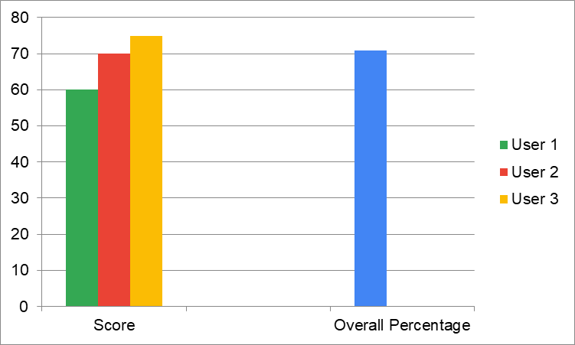

Our surveys gave us a broad understanding of what many people think and need. We asked questions to find out common problems and what features users would like the most. The results from the survey help us see the bigger picture and understand general user preferences for our figma Project. The survey shows that people find it easy to navigate through our app smoothly. The layout is well-organized, and clear, ensuring users of all ages can use this app without confusion.

**Interviews**

Talking to individual users in interviews gave us more detailed information. We could ask follow-up questions and understand why people had certain opinions or faced specific difficulties. These conversations provided rich insights into user behaviors and main points that we might not have discovered through surveys alone. This helped us understand the user experience on a deep level. We asked several friends for feedback on how the app might impact users, especially those with additional needs. Most of them shared that the app felt easy to use and well-organized. They mentioned that the labels and layout made it simple to understand where to go without needing extra guidance. Overall, they found it to be a clean, accessible, and user-friendly app experience.

**Persona creation**

To keep our design focused on the user, we created a persona. This is like an imaginary, typically user based on our research and we tried to implement the design to meet with real world applications. Our persona has specific goals, needs and frustrations. By designing for this specific persona, we can make sure our figma project meets the needs of our target audience and create a more user-centered design.